* Work Breakdown Structure diagram (WBS)

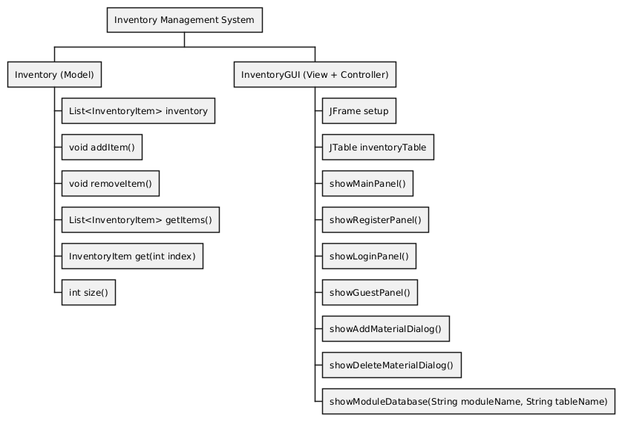

@startwbs

\* Inventory Management System

\*\* Inventory (Model)

\*\*\* List<InventoryItem> inventory

\*\*\* void addItem()

\*\*\* void removeItem()

\*\*\* List<InventoryItem> getItems()

\*\*\* InventoryItem get(int index)

\*\*\* int size()

\*\* InventoryGUI (View + Controller)

\*\*\* JFrame setup

\*\*\* JTable inventoryTable

\*\*\* showMainPanel()

\*\*\* showRegisterPanel()

\*\*\* showLoginPanel()

\*\*\* showGuestPanel()

\*\*\* showAddMaterialDialog()

\*\*\* showDeleteMaterialDialog()

\*\*\* showModuleDatabase(String moduleName, String tableName)

@endwbs